**WildBook**

**By**

**Ashish Reddy Pasham**

**A)**

**Database Schema:**

*Table 1:*

**User:**

1. **user_name**
2. first name
3. last name
4. email (UNIQUE)
5. user_pass
6. dob
7. gender
8. education
9. work
10. jointime
11. salt

*Table 2*

**Activity**

1. **activity_id**
2. activity_name

*Table 3*

**Posts**

1. **post_id**
2. activity_id **references Activity**
3. user_name **references User**
4. title
5. text_content (clob)
6. multimedia_content (blob)
7. location_id **references Location**
8. privacy_id **references Privacy**
9. timestamp
10. recipient

*Table 4*

**friends**

1. **user_name** references user.user_name
2. **friend_username** references user.user_name
3. accept (boolean)
4. timestamp

*Table 5*

**privacy**

1. **privacy_id**
2. **privacy_type**

*Table 6*

**Comments_posts**

1. **comment_id**
2. post_id **references posts**
3. user_name **references user.user_name**
4. comment_content (clob)
5. time stamp

*Table 7*

**post_likes (Weak)**

1. **post_id references posts**
2. **user_name references user.user_name**

*Table 8*

**activity_location_likes (Weak)**

1. **user_name references user.user_name**
2. **activity_id references Activity**
3. **location_id** **references Location**

*Table 9*

**activity_likes (Weak)**

1. **user_name references user.user_name**
2. **activity_id references Activity**

*Table 10*

**Login_attempts**

1. **email_id**
2. time

**ER-Diagram:**

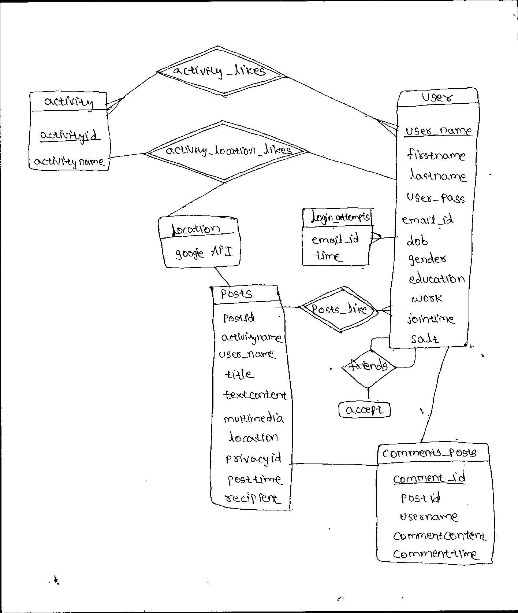

**B)**

-- phpMyAdmin SQL Dump

-- version 3.5.2.2

-- http://www.phpmyadmin.net

--

-- Host: 127.0.0.1

-- Generation Time: Apr 20, 2014 at 04:11 AM

-- Server version: 5.5.27

-- PHP Version: 5.4.7

SET SQL_MODE="NO_AUTO_VALUE_ON_ZERO";

SET time_zone = "+00:00";

/*!40101 SET @OLD_CHARACTER_SET_CLIENT=@@CHARACTER_SET_CLIENT */;

/*!40101 SET @OLD_CHARACTER_SET_RESULTS=@@CHARACTER_SET_RESULTS */;

/*!40101 SET @OLD_COLLATION_CONNECTION=@@COLLATION_CONNECTION */;

/*!40101 SET NAMES utf8 */;

--

-- Database: `wild`

--

CREATE DATABASE IF NOT EXISTS `wild` DEFAULT CHARACTER SET latin1 COLLATE latin1_swedish_ci;

USE `wild`;

-- --------------------------------------------------------

--

-- Table structure for table `activity`

--

CREATE TABLE IF NOT EXISTS `activity` (

`activityid` int(11) NOT NULL,

`activityname` varchar(50) NOT NULL,

PRIMARY KEY (`activityid`)

) ENGINE=InnoDB DEFAULT CHARSET=latin1;

-- --------------------------------------------------------

--

-- Table structure for table `activity_likes`

--

CREATE TABLE IF NOT EXISTS `activity_likes` (

`username` varchar(15) NOT NULL,

`activityid` int(11) NOT NULL

) ENGINE=InnoDB DEFAULT CHARSET=latin1;

-- --------------------------------------------------------

--

-- Table structure for table `activity_location_likes`

--

CREATE TABLE IF NOT EXISTS `activity_location_likes` (

`username` varchar(15) NOT NULL,

`activityid` int(11) NOT NULL,

`locationid` int(11) NOT NULL

) ENGINE=InnoDB DEFAULT CHARSET=latin1;

-- --------------------------------------------------------

--

-- Table structure for table `friends`

--

CREATE TABLE IF NOT EXISTS `friends` (

`username` varchar(15) NOT NULL,

`friendsusername` varchar(15) NOT NULL,

`accept` tinyint(1) DEFAULT '0',

`friendtime` timestamp NOT NULL DEFAULT CURRENT_TIMESTAMP ON UPDATE CURRENT_TIMESTAMP

) ENGINE=InnoDB DEFAULT CHARSET=latin1;

-- --------------------------------------------------------

--

-- Table structure for table `login_attempts`

--

CREATE TABLE IF NOT EXISTS `login_attempts` (

`user_id` varchar(255) NOT NULL,

`time` varchar(30) NOT NULL

) ENGINE=InnoDB DEFAULT CHARSET=latin1;

-- --------------------------------------------------------

--

-- Table structure for table `posts`

--

CREATE TABLE IF NOT EXISTS `posts` (

`postid` int(11) NOT NULL AUTO_INCREMENT,

`activityid` int(11) DEFAULT NULL,

`username` varchar(15) NOT NULL,

`title` varchar(50) NOT NULL,

`textcontent` text DEFAULT NULL,

`multimedia` longblob DEFAULT NULL,

`locationid` int(11) DEFAULT NULL,

`privacyid` int(11) DEFAULT '0',

`posttime` timestamp NOT NULL DEFAULT CURRENT_TIMESTAMP ON UPDATE CURRENT_TIMESTAMP,

PRIMARY KEY (`postid`)

) ENGINE=InnoDB DEFAULT CHARSET=latin1;

-- --------------------------------------------------------

--

-- Table structure for table `comments_posts`

--

CREATE TABLE IF NOT EXISTS `comments_posts` (

`commentid` int(11) NOT NULL AUTO_INCREMENT,

`postid` int(11) NOT NULL,

`username` varchar(15) NOT NULL,

`commentcontent` text NOT NULL,

`commenttime` timestamp NOT NULL DEFAULT CURRENT_TIMESTAMP ON UPDATE CURRENT_TIMESTAMP,

PRIMARY KEY (`commentid`)

) ENGINE=InnoDB DEFAULT CHARSET=latin1 AUTO_INCREMENT=1 ;

-- --------------------------------------------------------

--

-- Table structure for table `post_likes`

--

CREATE TABLE IF NOT EXISTS `post_likes` (

`postid` int(11) NOT NULL,

`username` varchar(15) NOT NULL

) ENGINE=InnoDB DEFAULT CHARSET=latin1;

-- --------------------------------------------------------

--

-- Table structure for table `privacy`

--

CREATE TABLE IF NOT EXISTS `privacy` (

`privacyid` int(11) NOT NULL AUTO_INCREMENT,

`privacyname` varchar(50) NOT NULL,

PRIMARY KEY (`privacyid`)

) ENGINE=InnoDB DEFAULT CHARSET=latin1 AUTO_INCREMENT=1 ;

-- --------------------------------------------------------

--

-- Table structure for table `user`

--

CREATE TABLE IF NOT EXISTS `user` (

`firstname` varchar(40) NOT NULL,

`lastname` varchar(40) NOT NULL,

`username` varchar(15) NOT NULL,

`email` varchar(50) NOT NULL,

`password` varchar(50) NOT NULL,

`dob` date NOT NULL,

`gender` char(1) DEFAULT NULL,

`education` varchar(200) DEFAULT NULL,

`work` varchar(200) DEFAULT NULL,

`jointime` timestamp NOT NULL DEFAULT CURRENT_TIMESTAMP ON UPDATE CURRENT_TIMESTAMP,

`privacyid` int(11) DEFAULT '0',

PRIMARY KEY (`username`)

) ENGINE=InnoDB DEFAULT CHARSET=latin1;

-- phpMyAdmin SQL Dump

-- version 4.0.4

-- http://www.phpmyadmin.net

--

-- Host: localhost

-- Generation Time: May 13, 2014 at 07:16 PM

-- Server version: 5.6.12-log

-- PHP Version: 5.4.16

SET SQL_MODE = "NO_AUTO_VALUE_ON_ZERO";

SET time_zone = "+00:00";

/*!40101 SET @OLD_CHARACTER_SET_CLIENT=@@CHARACTER_SET_CLIENT */;

/*!40101 SET @OLD_CHARACTER_SET_RESULTS=@@CHARACTER_SET_RESULTS */;

/*!40101 SET @OLD_COLLATION_CONNECTION=@@COLLATION_CONNECTION */;

/*!40101 SET NAMES utf8 */;

--

-- Database: `wild`

--

CREATE DATABASE IF NOT EXISTS `wild` DEFAULT CHARACTER SET latin1 COLLATE latin1_swedish_ci;

USE `wild`;

-- --------------------------------------------------------

--

-- Table structure for table `activity`

--

CREATE TABLE IF NOT EXISTS `activity` (

`activityid` int(11) NOT NULL,

`activityname` varchar(50) NOT NULL,

PRIMARY KEY (`activityid`)

) ENGINE=InnoDB DEFAULT CHARSET=latin1;

--

-- Dumping data for table `activity`

--

INSERT INTO `activity` (`activityid`, `activityname`) VALUES

(0, 'Trekking\r');

-- --------------------------------------------------------

--

-- Table structure for table `activity_likes`

--

CREATE TABLE IF NOT EXISTS `activity_likes` (

`user_name` varchar(15) NOT NULL,

`activityid` int(11) NOT NULL,

KEY `user_name` (`user_name`),

KEY `activityid` (`activityid`)

) ENGINE=InnoDB DEFAULT CHARSET=latin1;

-- --------------------------------------------------------

--

-- Table structure for table `activity_location_likes`

--

CREATE TABLE IF NOT EXISTS `activity_location_likes` (

`user_name` varchar(15) NOT NULL,

`activityid` int(11) NOT NULL,

`locationid` int(11) NOT NULL,

KEY `user_name` (`user_name`),

KEY `activityid` (`activityid`),

KEY `locationid` (`locationid`)

) ENGINE=InnoDB DEFAULT CHARSET=latin1;

-- --------------------------------------------------------

--

-- Table structure for table `comments_posts`

--

CREATE TABLE IF NOT EXISTS `comments_posts` (

`commentid` int(11) NOT NULL AUTO_INCREMENT,

`postid` int(11) NOT NULL,

`user_name` varchar(15) NOT NULL,

`commentcontent` text NOT NULL,

`commenttime` timestamp NOT NULL DEFAULT CURRENT_TIMESTAMP ON UPDATE CURRENT_TIMESTAMP,

PRIMARY KEY (`commentid`),

KEY `user_name` (`user_name`),

KEY `postid` (`postid`)

) ENGINE=InnoDB DEFAULT CHARSET=latin1 AUTO_INCREMENT=20 ;

--

-- Dumping data for table `comments_posts`

--

INSERT INTO `comments_posts` (`commentid`, `postid`, `user_name`, `commentcontent`, `commenttime`) VALUES

(1, 21, 'kaushik', 'test comment', '2014-05-09 02:05:06'),

(6, 43, 'kaushik', 'xyz', '2014-05-11 18:00:37'),

(7, 43, 'kaushik', 'xyz', '2014-05-11 18:01:13'),

(8, 43, 'kaushik', 'edo le', '2014-05-11 18:03:59'),

(9, 43, 'kaushik', 'idedo baagunde cheli', '2014-05-11 18:04:27'),

(10, 43, 'kaushik', 'idi kuuda', '2014-05-11 18:16:37'),

(11, 42, 'kaushik', 'here', '2014-05-11 18:16:48'),

(12, 32, 'kaushik', 'comment', '2014-05-11 21:55:55'),

(13, 32, 'kaushik', 'comment', '2014-05-11 21:56:13'),

(14, 1, 'kaushik', 'hi', '2014-05-12 02:32:27'),

(15, 1, 'kaushik', 'hi2', '2014-05-12 09:26:25'),

(16, 3, 'kaushik', 'hkl', '2014-05-12 09:46:21'),

(17, 5, 'kaushik', 'hello', '2014-05-12 19:02:45'),

(18, 8, 'kaushik', 'comment', '2014-05-13 00:57:43'),

(19, 19, 'ashash', 'what the \r\n', '2014-05-13 08:43:18');

-- --------------------------------------------------------

--

-- Table structure for table `friends`

--

CREATE TABLE IF NOT EXISTS `friends` (

`user_name` varchar(64) NOT NULL,

`friendsusername` varchar(64) NOT NULL,

`accept` int(11) NOT NULL DEFAULT '0'

) ENGINE=InnoDB DEFAULT CHARSET=latin1;

--

-- Dumping data for table `friends`

--

INSERT INTO `friends` (`user_name`, `friendsusername`, `accept`) VALUES

('kaushik', 'santosh', 0);

-- --------------------------------------------------------

--

-- Table structure for table `location`

--

CREATE TABLE IF NOT EXISTS `location` (

`locationid` int(11) NOT NULL AUTO_INCREMENT,

`locationname` varchar(200) NOT NULL,

`latitude` decimal(10,8) DEFAULT NULL,

`longitude` decimal(11,8) DEFAULT NULL,

PRIMARY KEY (`locationid`)

) ENGINE=InnoDB DEFAULT CHARSET=latin1 AUTO_INCREMENT=1 ;

-- --------------------------------------------------------

--

-- Table structure for table `login_attempts`

--

CREATE TABLE IF NOT EXISTS `login_attempts` (

`user_id` varchar(255) NOT NULL,

`time` varchar(30) NOT NULL

) ENGINE=InnoDB DEFAULT CHARSET=latin1;

--

-- Dumping data for table `login_attempts`

--

INSERT INTO `login_attempts` (`user_id`, `time`) VALUES

('kaushik1091@gmail.com', '1399497434'),

('kaushik1091@gmail.com', '1399497445');

-- --------------------------------------------------------

--

-- Table structure for table `posts`

--

CREATE TABLE IF NOT EXISTS `posts` (

`postid` int(11) NOT NULL AUTO_INCREMENT,

`activityname` varchar(50) DEFAULT NULL,

`user_name` varchar(15) NOT NULL,

`title` varchar(50) DEFAULT NULL,

`textcontent` text,

`multimedia` longblob,

`location` varchar(64) DEFAULT NULL,

`privacyid` varchar(30) DEFAULT 'public',

`posttime` timestamp NOT NULL DEFAULT CURRENT_TIMESTAMP ON UPDATE CURRENT_TIMESTAMP,

`recipient` varchar(30) DEFAULT NULL,

PRIMARY KEY (`postid`),

KEY `user_name` (`user_name`)

) ENGINE=InnoDB DEFAULT CHARSET=latin1 AUTO_INCREMENT=22 ;

--

-- Dumping data for table `posts`

--

INSERT INTO `posts` (`postid`, `activityname`, `user_name`, `title`, `textcontent`, `multimedia`, `location`, `privacyid`, `posttime`, `recipient`) VALUES

(1, '', 'kaushik', 'Test', 'test', NULL, 'New York, NY, United States', 'public', '2014-05-12 02:31:57', ''),

(2, 'hiking', 'kaushik', '', 'test', NULL, '', 'public', '2014-05-12 03:34:48', ''),

(3, 'jogging', 'kaushik', 'Test', 'test', NULL, 'New York, NY, United States', 'public', '2014-05-12 03:39:56', ''),

(4, '', 'kaushik', 'test', 'test this too', NULL, 'London, United Kingdom', 'public', '2014-05-12 18:44:52', ''),

(5, '', 'kaushik', '', 'hi', NULL, 'Brooklyn, NY, United States', 'public', '2014-05-12 18:58:42', 'santosh'),

(6, 'jogging', 'kaushik', 'test', 'test1', NULL, 'Chicago, IL, United States', 'public', '2014-05-13 00:56:32', ''),

(7, 'jogging', 'kaushik', 'test', 'test1', NULL, 'Chicago, IL, United States', 'public', '2014-05-13 00:57:09', ''),

(8, '', 'kaushik', 'djafL', 'ldskfksd', NULL, 'Enwright Dr, Fairport, NY, United States', 'public', '2014-05-13 00:57:24', ''),

(11, '', 'kaushik', '', '', '', '', 'public', '2014-05-13 01:26:02', ''),

(12, '', 'kaushik', '', '', '', '', 'public', '2014-05-13 01:26:48', ''),

(13, '', 'kaushik', '', '', '', '', 'public', '2014-05-13 01:27:53', ''),

(14, '', 'kaushik', '', '', '', '', 'public', '2014-05-13 01:28:31', ''),

(15, '', 'kaushik', '', '', '', '', 'public', '2014-05-13 01:29:37', ''),

(16, '', 'kaushik', '', '', '', '', 'public', '2014-05-13 01:37:42', ''),

(17, '', 'kaushik', '', '', '', '', 'public', '2014-05-13 01:40:16', ''),

(18, '', 'kaushik', '', '', '', '', 'public', '2014-05-13 01:42:29', ''),

(19, '', 'kaushik', '', '', '', '', 'public', '2014-05-13 01:43:47', ''),

(20, '', 'ashash', '', '', NULL, '', 'public', '2014-05-13 03:26:25', ''),

(21, '', 'ashash', '', '', NULL, '', 'public', '2014-05-13 03:26:28', '');

-- --------------------------------------------------------

--

-- Table structure for table `post_likes`

--

CREATE TABLE IF NOT EXISTS `post_likes` (

`postid` int(11) NOT NULL,

`user_name` varchar(15) NOT NULL,

KEY `user_name` (`user_name`),

KEY `postid` (`postid`)

) ENGINE=InnoDB DEFAULT CHARSET=latin1;

--

-- Dumping data for table `post_likes`

--

INSERT INTO `post_likes` (`postid`, `user_name`) VALUES

(2, 'kaushik'),

(1, 'kaushik'),

(5, 'kaushik'),

(4, 'kaushik'),

(21, 'ashash');

-- --------------------------------------------------------

--

-- Table structure for table `users`

--

CREATE TABLE IF NOT EXISTS `users` (

`user_id` varchar(64) NOT NULL,

`user_name` varchar(30) NOT NULL,

`firstname` varchar(40) NOT NULL,

`lastname` varchar(40) NOT NULL,

`user_pass` varchar(255) NOT NULL,

`dob` date NOT NULL,

`gender` varchar(10) DEFAULT NULL,

`education` varchar(200) DEFAULT NULL,

`work` varchar(200) DEFAULT NULL,

`jointime` timestamp NOT NULL DEFAULT CURRENT_TIMESTAMP ON UPDATE CURRENT_TIMESTAMP,

`salt` varchar(128) NOT NULL,

PRIMARY KEY (`user_name`),

UNIQUE KEY `user_id` (`user_id`)

) ENGINE=InnoDB DEFAULT CHARSET=latin1;

--

-- Dumping data for table `users`

--

INSERT INTO `users` (`user_id`, `user_name`, `firstname`, `lastname`, `user_pass`, `dob`, `gender`, `education`, `work`, `jointime`, `salt`) VALUES

('ash@ash.com', 'ashash', '', '', 'c53460271f11bdef2e542c762c30b58606e4ddd215a3f0d7686f3f2ec849d020b4f4377d408fa5df07541a17f3f7fcebfa7a0475d3c7919212c0fc33d5754c3e', '0000-00-00', NULL, NULL, NULL, '2014-05-13 03:02:24', '56d681df6e5e7f11f0af4bfc22bc15627351ec3e6e2951a94c4eb6e4751f4fe02323e90284f93b2c2b2582a86b72b37199a6859f26ae28f9af41290f2eb06c55'),

('kaushik1091@gmail.com', 'kaushik', 'Kaushik', 'Borra', '48af41981e5654ce4495118363f1c82130a1e639d59ea8e16da17e0f5ce20411827c123c963febc390c725674a737addbdaf6c770e4d1480ce1f6ee43d7e5990', '1991-10-26', 'Male', 'NYU Polytechnic School of Engineering', 'Google', '2014-05-13 00:59:08', 'f221b10b2c792159ff0410fd26a6532315dd8872bec7dbfda0a7287d5c69ad148a73e1a98af50320967a6c60ff910488f36df98809e835496df565619c7f939c'),

('s.sunny1992@gmail.com', 'santosh', 'Santosh', 'Somavarapu', '8d82959ab2ef17a6def8f25813a028307562216b4a3d5f34837a8bbee7d93b48a12992caa9f60fe82274dd66b518f397eed0734b9a7a501b1c1ba7b2abf4661b', '1992-03-17', 'Male', 'NYU Poly', NULL, '2014-05-10 05:22:03', '768718790663fb3f459f55b03bf4c8a4ef5896f9a14b72f9827f4dc997464d7928c4ce20de34486d8b9098e017e5deba91c9d2452d214f7df30c36890d372c5b');

--

-- Constraints for dumped tables

--

--

-- Constraints for table `activity_likes`

--

ALTER TABLE `activity_likes`

ADD CONSTRAINT `activity_likes_ibfk_1` FOREIGN KEY (`user_name`) REFERENCES `users` (`user_name`),

ADD CONSTRAINT `activity_likes_ibfk_2` FOREIGN KEY (`activityid`) REFERENCES `activity` (`activityid`);

--

-- Constraints for table `activity_location_likes`

--

ALTER TABLE `activity_location_likes`

ADD CONSTRAINT `activity_location_likes_ibfk_1` FOREIGN KEY (`user_name`) REFERENCES `users` (`user_name`),

ADD CONSTRAINT `activity_location_likes_ibfk_2` FOREIGN KEY (`activityid`) REFERENCES `activity` (`activityid`),

ADD CONSTRAINT `activity_location_likes_ibfk_3` FOREIGN KEY (`locationid`) REFERENCES `location` (`locationid`);

--

-- Constraints for table `comments_posts`

--

ALTER TABLE `comments_posts`

ADD CONSTRAINT `comments_posts_ibfk_1` FOREIGN KEY (`user_name`) REFERENCES `users` (`user_name`),

ADD CONSTRAINT `comments_posts_ibfk_2` FOREIGN KEY (`postid`) REFERENCES `posts` (`postid`);

--

-- Constraints for table `posts`

--

ALTER TABLE `posts`

ADD CONSTRAINT `posts_ibfk_1` FOREIGN KEY (`user_name`) REFERENCES `users` (`user_name`);

--

-- Constraints for table `post_likes`

--

ALTER TABLE `post_likes`

ADD CONSTRAINT `post_likes_ibfk_1` FOREIGN KEY (`user_name`) REFERENCES `users` (`user_name`),

ADD CONSTRAINT `post_likes_ibfk_2` FOREIGN KEY (`postid`) REFERENCES `posts` (`postid`);

/*!40101 SET CHARACTER_SET_CLIENT=@OLD_CHARACTER_SET_CLIENT */;

/*!40101 SET CHARACTER_SET_RESULTS=@OLD_CHARACTER_SET_RESULTS */;

/*!40101 SET COLLATION_CONNECTION=@OLD_COLLATION_CONNECTION */;

**C)**

**1.**

**Query if user needs to sign Up:**

Insert into user (firstname, lastname, username,email,password,dob) values (‘given’, ‘given’, ‘given’, ‘given’, ‘given’, ‘given’);

**Query if user create or edit profile:**

Insert into user (firstname, lastname, password,dob,password) values (‘given’, ‘given’, ‘given’, ‘given’, ‘given’);

**Query to post an image with or without some text:**

Insert into posts(username, title, textcontent, multimedia) values (‘given’, ‘given’,’ given’,’ given’);

**Query to add an entry to User’s activity diary:**

Select activityid from activity where activityname=‘given’;

Insert into posts_activity(activityid,textcontent,multimedia) values(‘obtained’, ‘given’, ‘given’)

**2.**

**Query to add someone as a friend:**

Insert into friends (username, friendusername) values(‘given’, ‘given’);

**Query to accept someone as a friend:**

Insert into friends (accept) values(1) where friendusername=’given’ and username=’given’;

**3.**

--Here privacyid=0 means open to everyone

--Here privacyid=1 means open only to friends of friends

--Here privacyid=2 means open only to friends

--Here privacyid=3 means private

**Query if user wants to see all profiles of his friends:**

Select firstname,lastname,username,email,dob from user where username=(Select friendusername from friends where username=’given’ and accept=1 union Select username from friends where friendusername =’given’ and accept=1) and privacyid=0 or 1 or 2;

**Query if user wants to see all diary entries by his friends:**

Select title, textcontent, multimedia from posts where username=(Select friendusername from friends where username=’given’ and accept=1 union Select username from friends where friendusername =’given’ and accept=1) and privacyid=0 or 1 or 2;

**Query if user wants to see all profiles of his friends of friends:**

With FList as(Select friendusername from friends where username=’given’ and accept=1 union Select username from friends where friendusername =’given’ and accept=1)

Select firstname,lastname,username,email,dob from user where username=(Select distinct FOFList (Select friendusername from friends where username in FList and accept=1 union Select username from friends where friendusername in FList and accept=1)) and privacyid=0 or 1;

**Query if user wants to see all diary entries by his friends of friends:**

With FList as(Select friendusername from friends where username=’given’ and accept=1 union Select username from friends where friendusername =’given’ and accept=1)

Select title, textcontent, multimedia from posts where username=(Select distinct FOFList (Select friendusername from friends where username in FList and accept=1 union Select username from friends where friendusername in FList and accept=1)) privacyid=0 or 1;

**Query if user wants to see all diary entries by everyone that contain keyword fishing:**

Select title, textcontent, multimedia from posts where textcontent like %fishing%

**Query if user wants to see all diary entries by his friends during the last week:**

Select title, textcontent, multimedia from posts where username=(Select friendusername from friends where username=’given’ and accept=1 union Select username from friends where friendusername =’given’ and accept=1) and privacyid=0 or 1 or 2 and posttime between curdate()-interval 1 week and curdate();

**Query if user wants to see all locations liked by his friends:**

Select locationname from location where locationid=(select locationid from activity_location_likes where username=(Select friendusername from friends where username=’given’ and accept=1 union Select username from friends where friendusername =’given’ and accept=1) );

**Query if user wants to see all locations popular for fishing:**

Select locationname from location where locationid=(select locationid from activity_location_likes t1 join activity t2 on t1.activityid= t2.activityid where activity=’fishing’);

**D)**

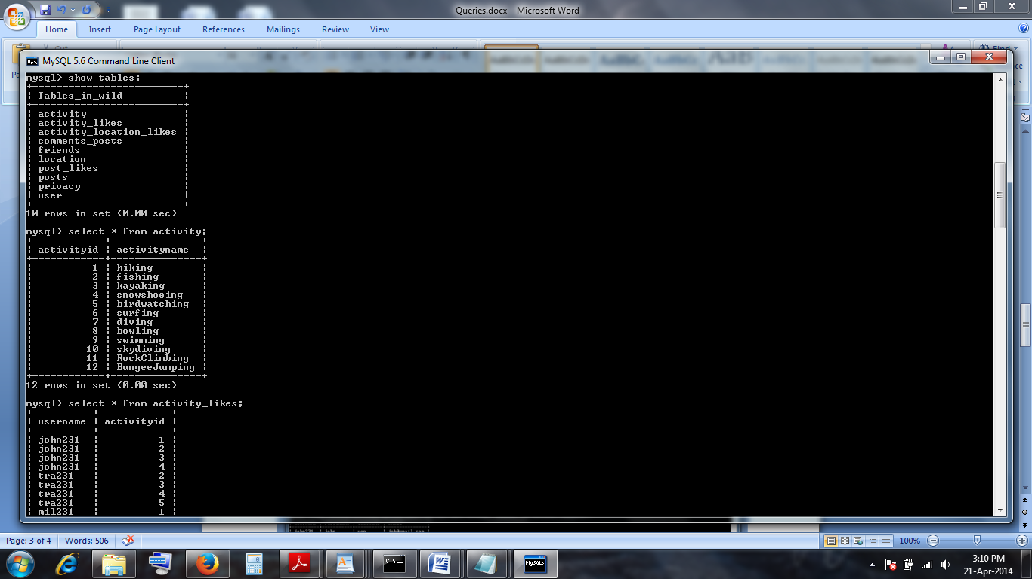

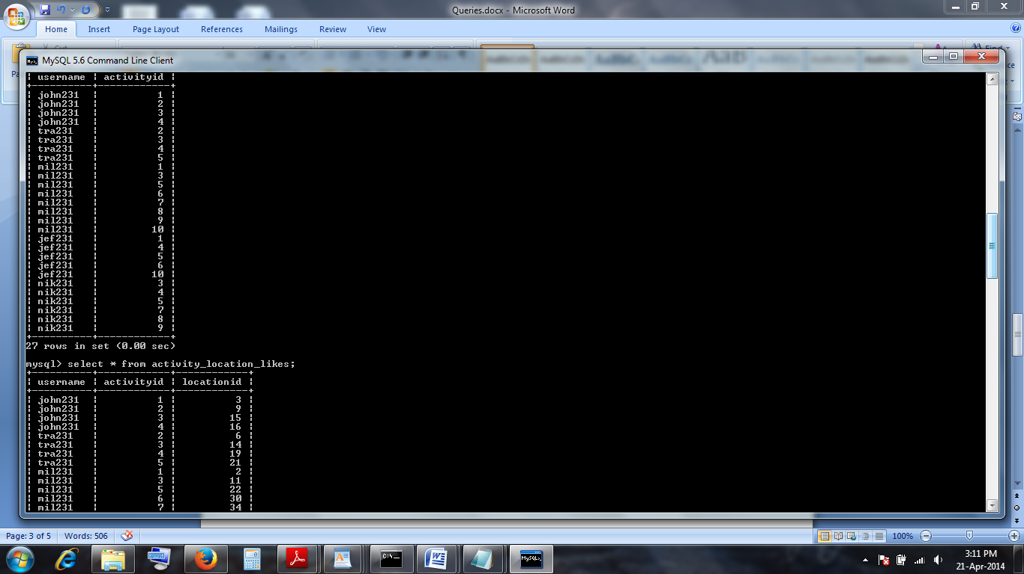

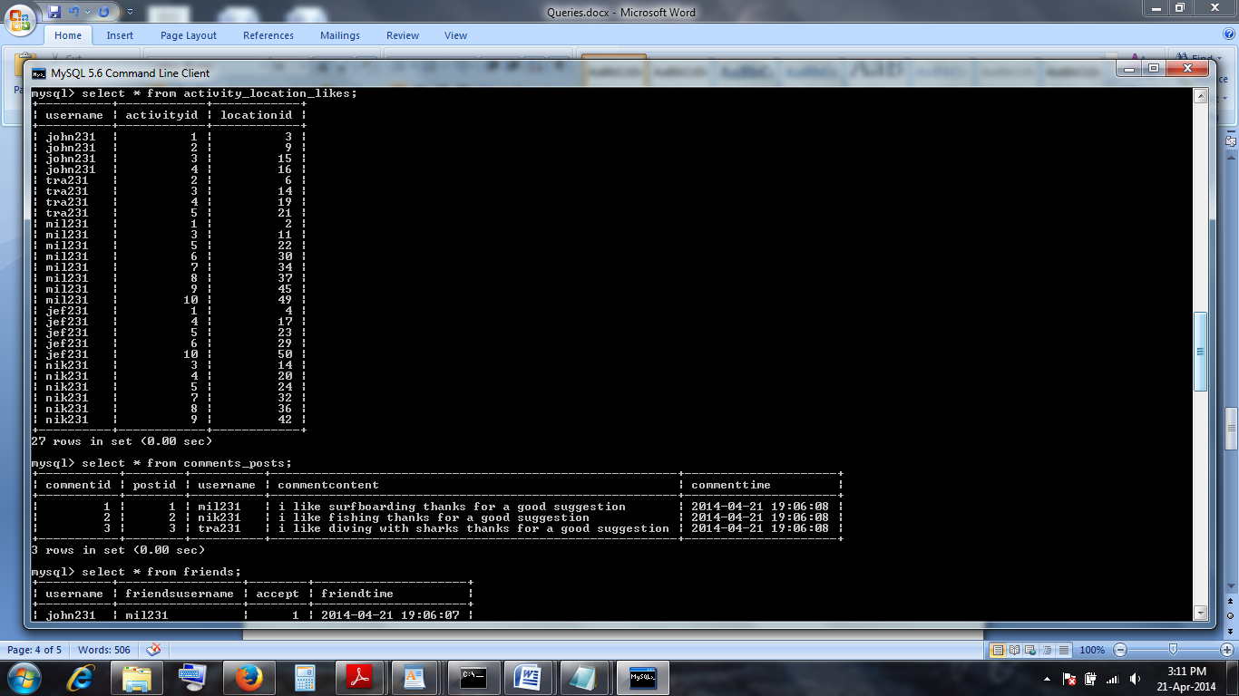

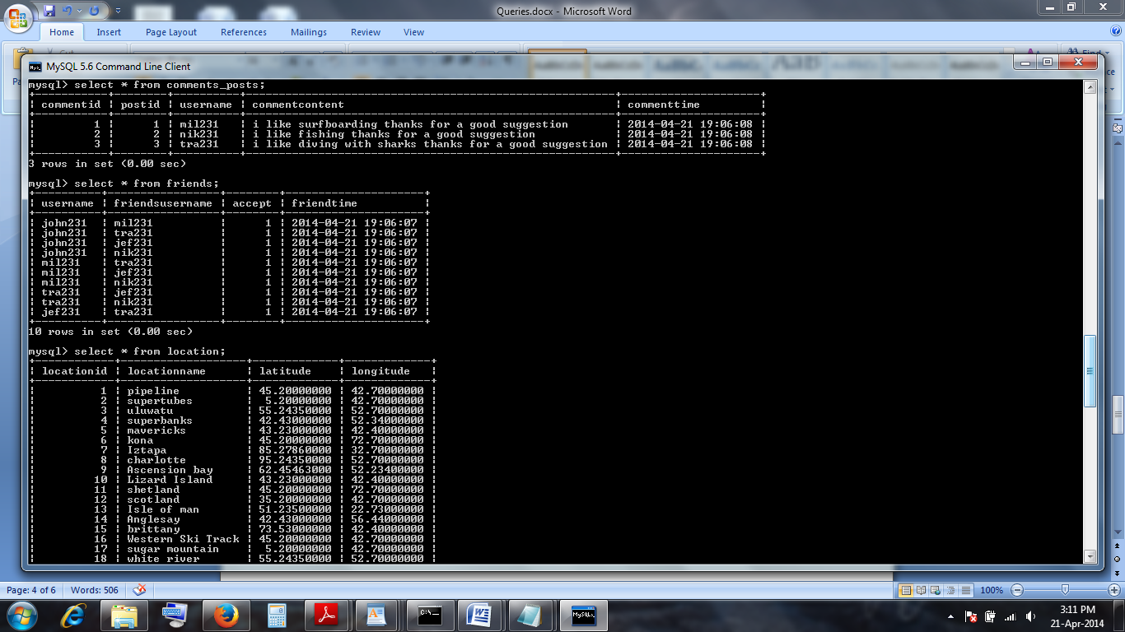

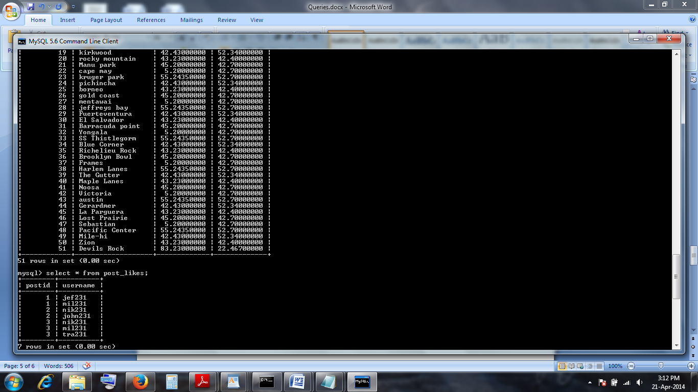

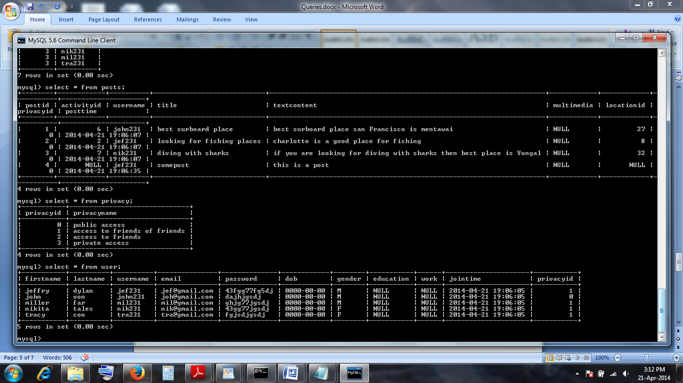

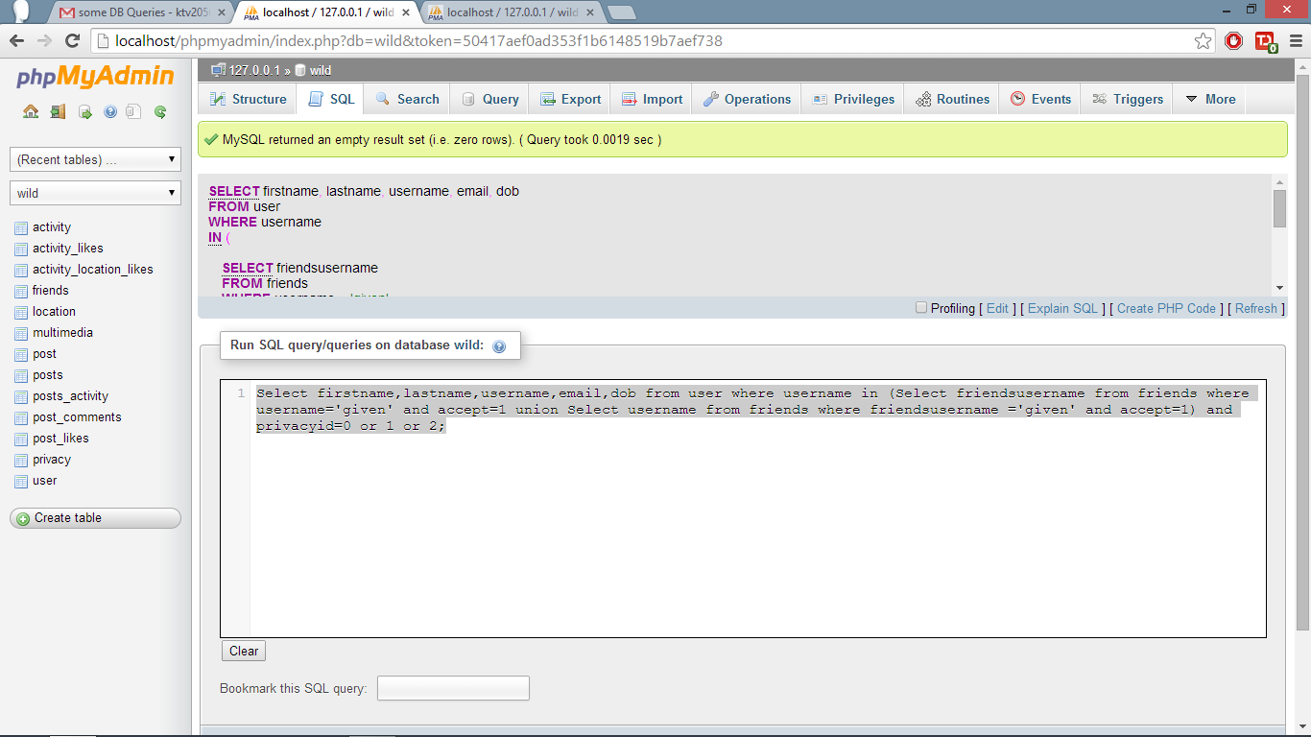

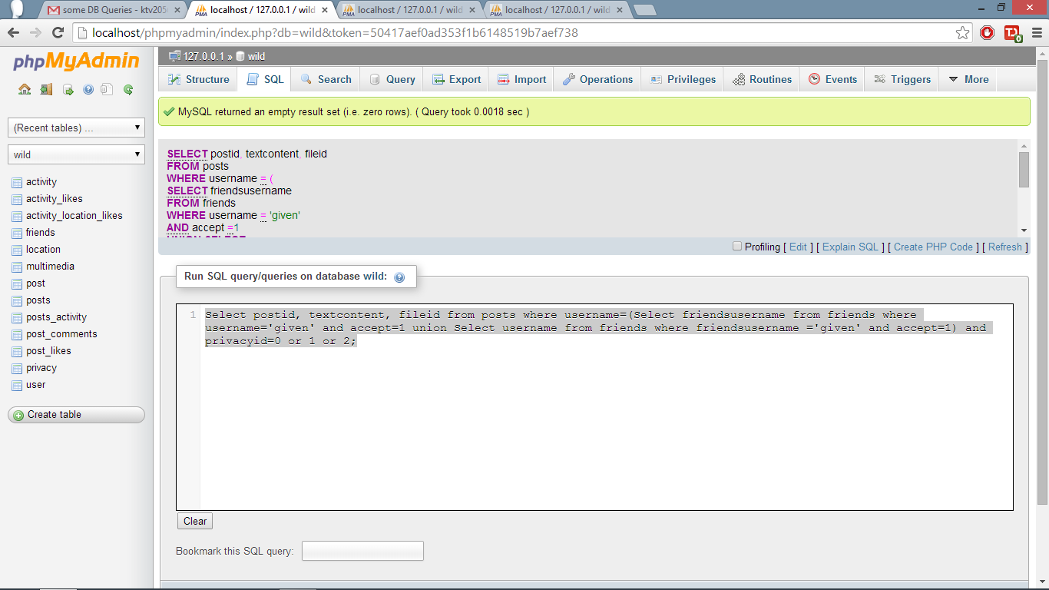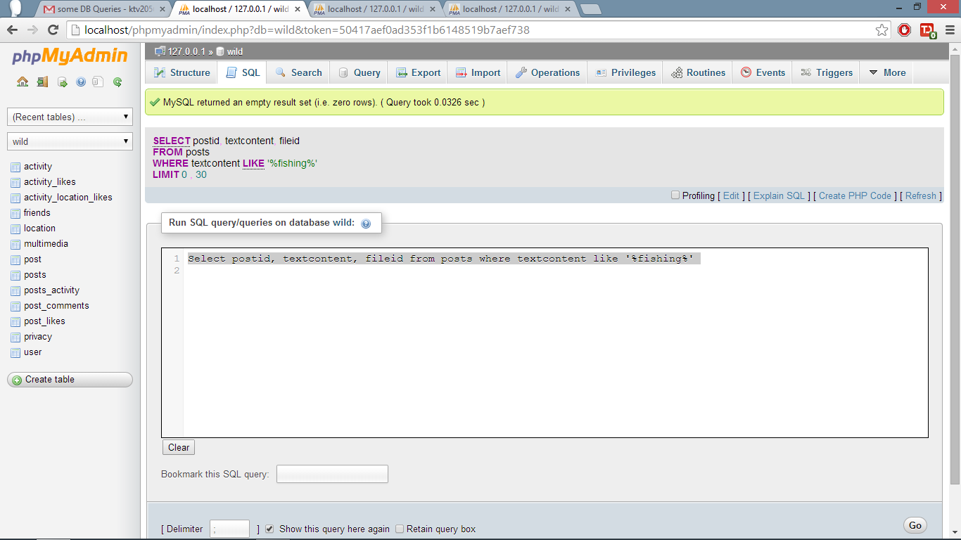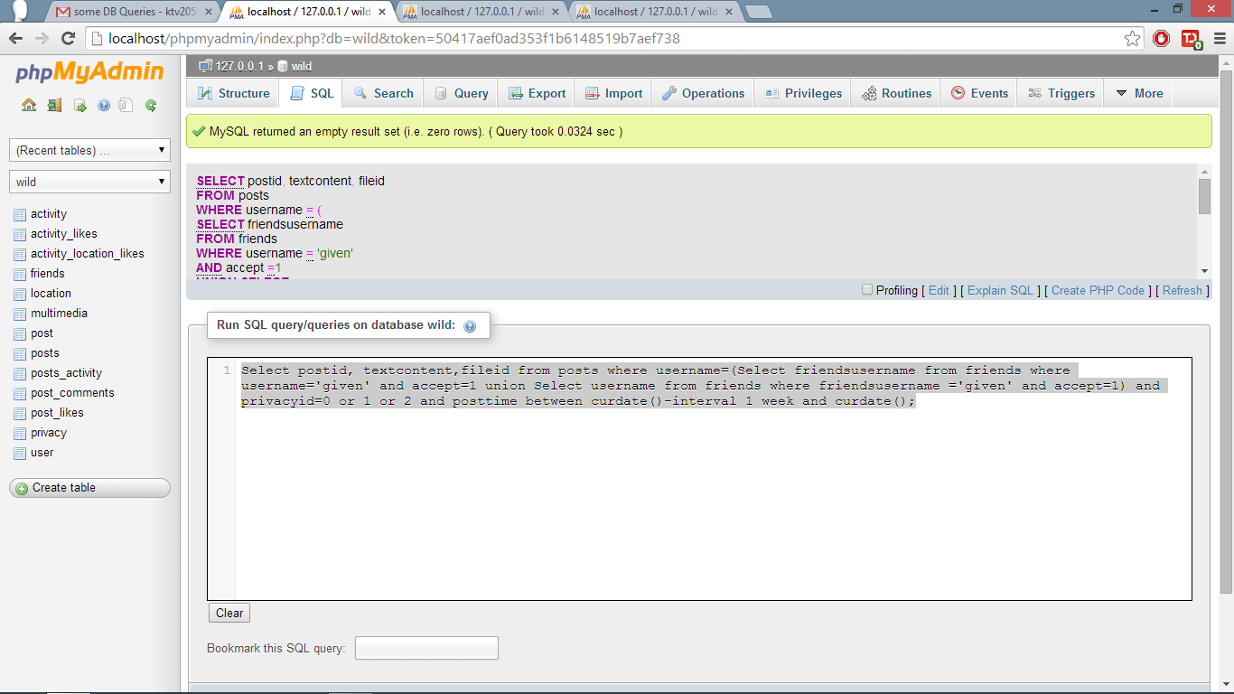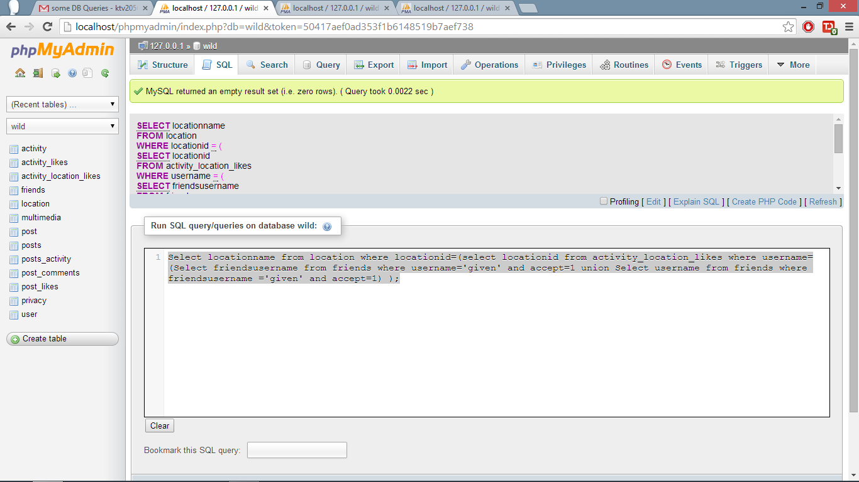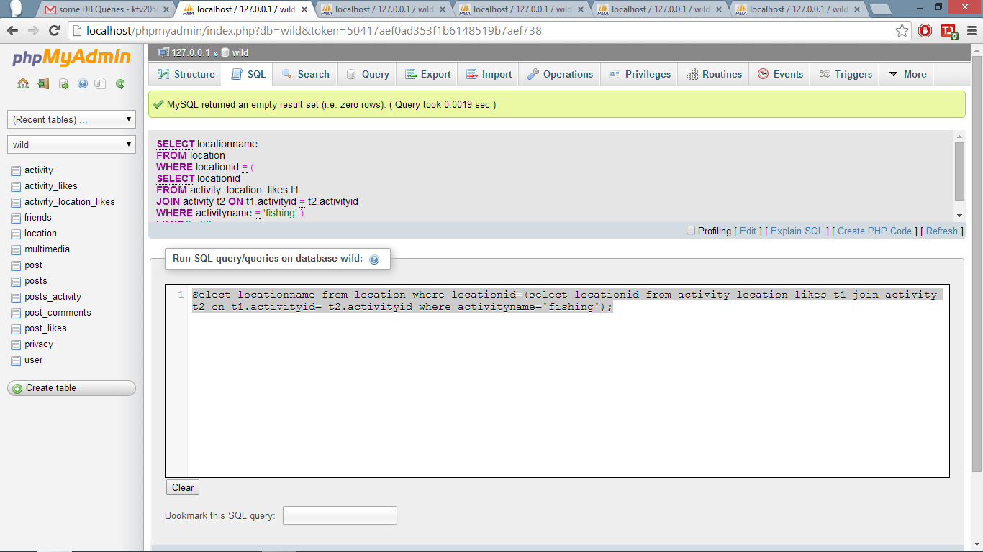

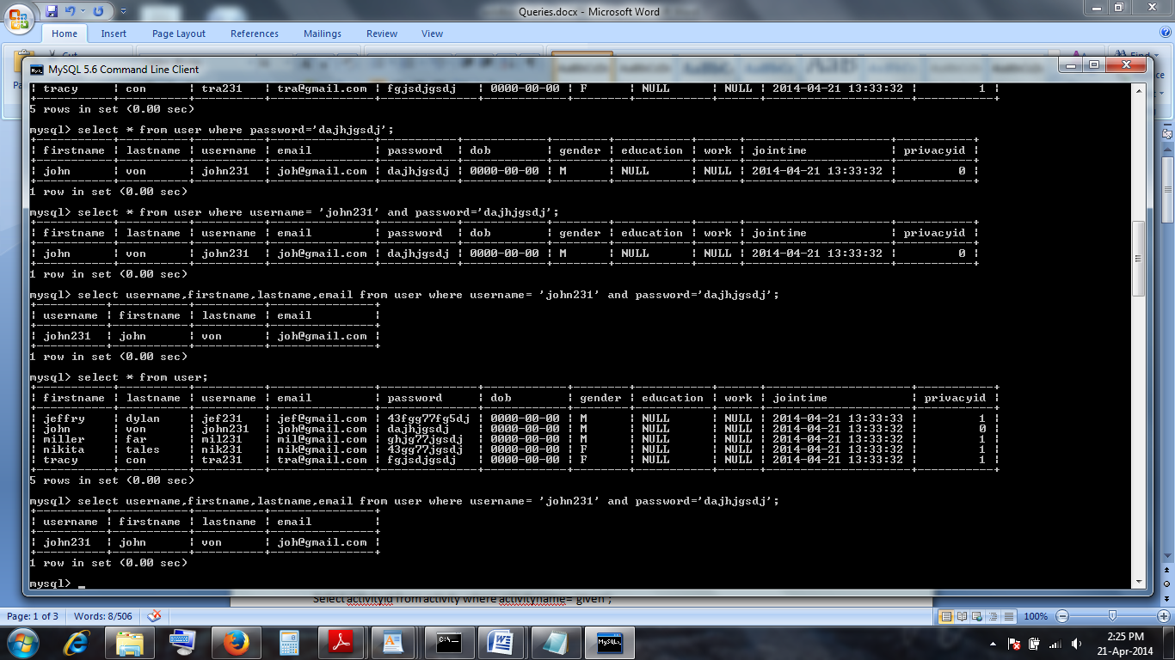

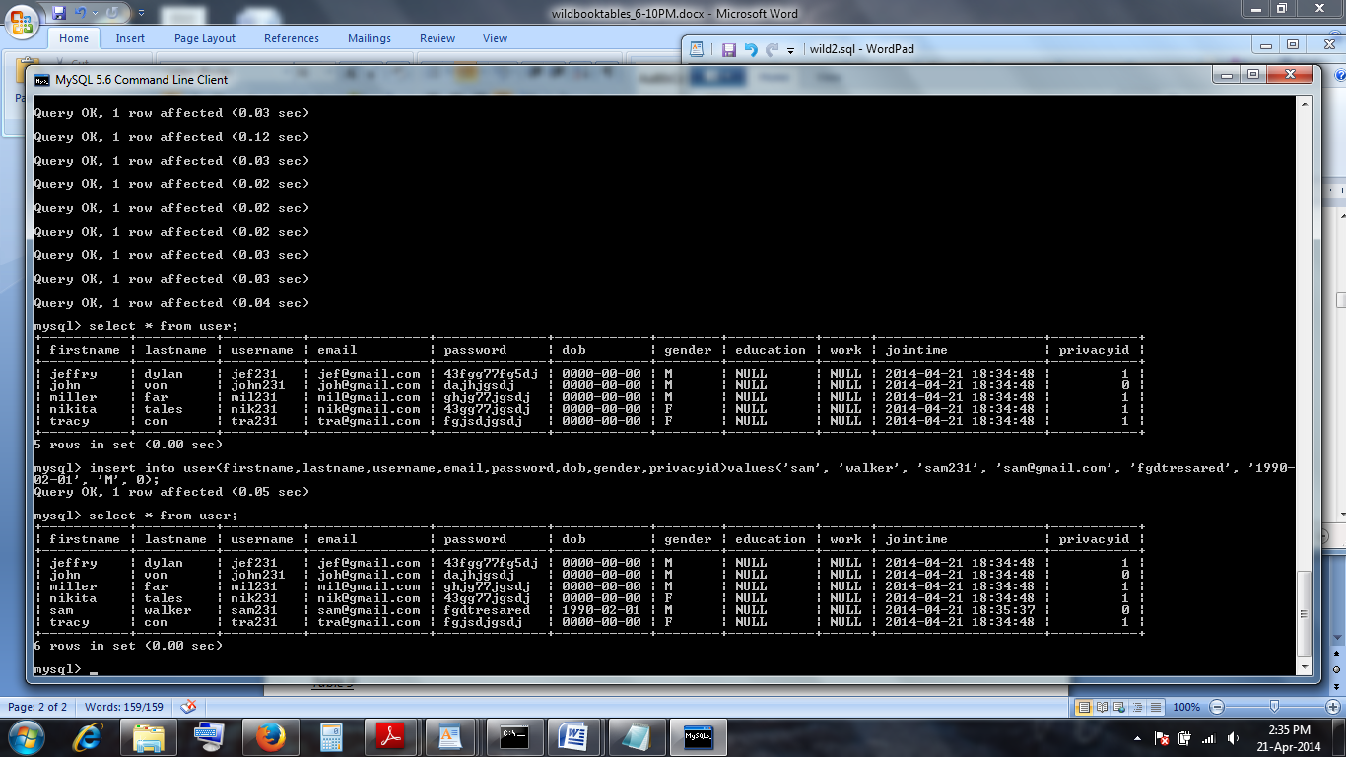

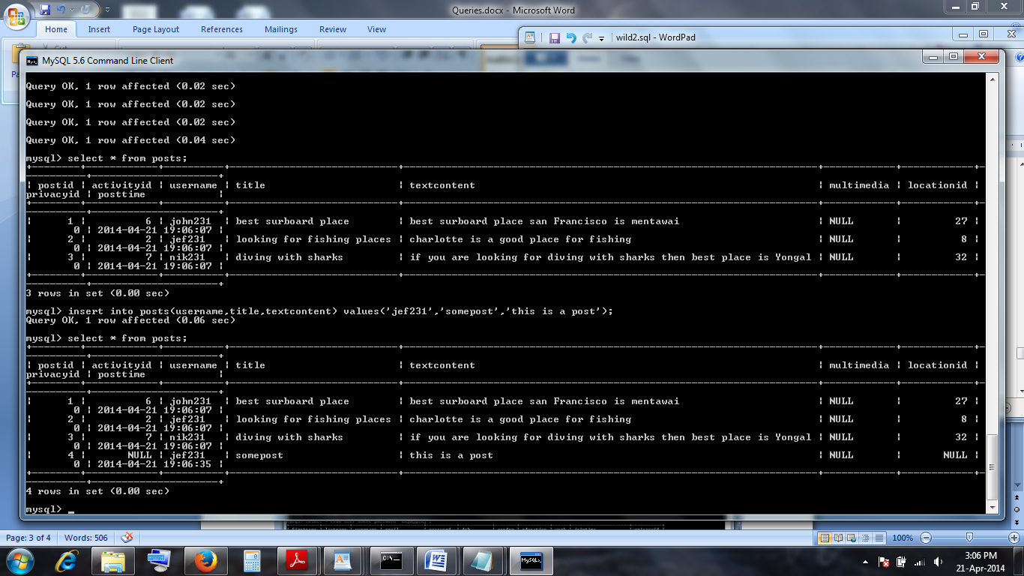

**E)Some Stored Procedues**

1.

**LIST OF ALL FRIENDS OF A USER**

DELIMITER $$  
  
CREATE procedure friends (IN uname varchar)  
    BEGIN  
        SELECT username FROM friends WHERE friend_username=uname  
        UNION  
        SELECT friend_username FROM friends WHERE username=uname;  
    END $$  
DELIMITER ;  
....................  
CALL friends('John')  
````````````````````  
2.  
**ALL YOUR FRIENDS WHO LIKE AN ACTIVITY AS YOU DO**  
  
DELIMITER $$  
  
CREATE procedure factlike(IN uname varchar, IN act varchar)  
    BEGIN  
        CALL friends(uname)  
        INTERSECT  
        SELECT username FROM activity_likes WHERE activityid=act;  
    END $$  
DELIMITER ;  
....................  
CALL factlike('John','hiking')  
````````````````````

3.  
**SEARCH FOR ALL POSTS WITH GIVEN KEYWORD**

CREATE procedure search(IN searchword varchar)  
    BEGIN  
       SELECT title, textcontent, multimedia From posts where textcontent like %searchword%;

    END $$  
DELIMITER ;  
....................  
CALL search('John','hiking')

**F)**

We have an activity table with activity id. Any new activity entered by any user will be updated into the activity table.

Location details are obtained using Google APIs.

User table contains all the mandatory and optional fields related to the user. The fields username and email are unique and cannot be changed. The fields firstname, lastname, dob along with username and email should be given to create a new profile. Age can be calculated from date of birth. The fields gender, education, work are optional and includes in the profile. The field privacyid gives the privacy status of his profile and friends list info. By default it is 0 which means public.

Friends table is inserted whenever a user sends friend request to another user with status 0. If the other user accepts it, status is changed to 1.

Posts table contains all the posts with a unique post id. A post may be associated with a activity or may be not. All the posts associated with an activity can be called as an activity diary and users can get their activity diaries. Every post ever posted will have a title(not necessarily unique) with default privacyid as public. Every post can be associated to a location. If a new location is entered, it has to entered in to location table too. Multimedia and text content may present together in any post. Blob has been used to hold multimedia content and text has been used to hold large textcontent.

Post_Likes table contains all the postids which are liked by any users along with username. Count of the number of likes of a post can be obtained from number of entries in this table for that postid.

Comments_posts table contains all the comments related to a specific post. A comment cannot exist with an actual post related to it. There can be any number of comments for a specific post.

Activity_likes table contains all the usernames along with their liked activities. This is be added in User profiles if needed.

Activity_Location_Likes contains all the locations that a user likes with respect to any activity.

Privacy table just holds the actual permission information about the privacyid with respect to the actual permission description. For example, permission description could be only for friends or friends of friends or everyone or no one.

Technologies like JDBC and PHP can be used to access databases from web based inputs and these have been installed and configured in our systems.

Every user (uniquely identified by a username) will have to sign-up to post and search for the information. A user can change his privacy policy for his profiles and also for postings. He can change visibility to everyone or only friends of friends or only friends or totally private.

Timestamp has been maintained for every post, profile, friend request and other events so that they can be listed according to time.

The project is designed using PHPmyadmin and mysql database in the wamp server. Every user should login to be able to use the wildbook. New users should be able to register usinf their emailId, username, password. Password should contain atleast one letter, number and a special character. Once the user registers and logs in, he can see Home, username(profile) and Logout on the navigation bar. Every post have title, content, activity, location, Upload Image. We can also add privacy settings which says accessible to either friends or friends of friends of to everyone.

Once a post is posted, it can be added with a number of comments and posts can be liked by users. To add an activity, click on the activity button. To add a Location, click on the location, to add a image click on the upload button. Every post also has a like button which can be used to like the post.

Location is obtained using google API. If we click on the username in the navigation bar, we will be redirected to the profile page. Profile page is the activity diary which consists of the users own posts along with his profile. Home page displays all the posts of the users friends which are accessible.

This is the login(sign-in) Page:

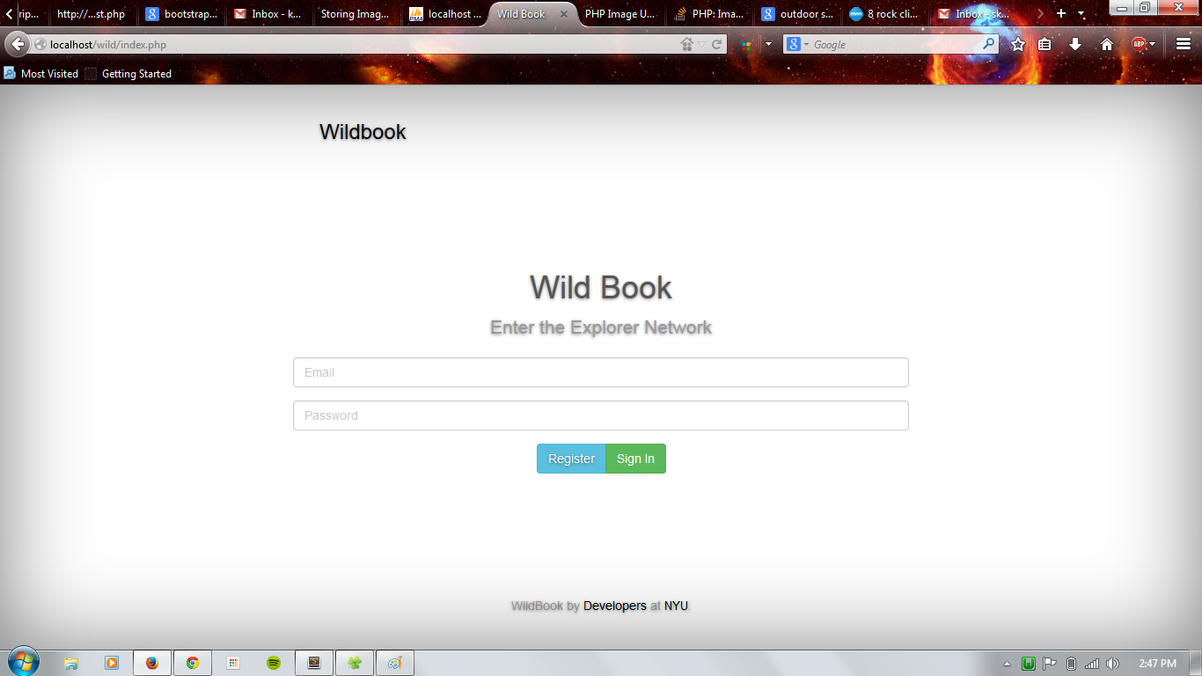

For the first time, you have to sign-Up(register):

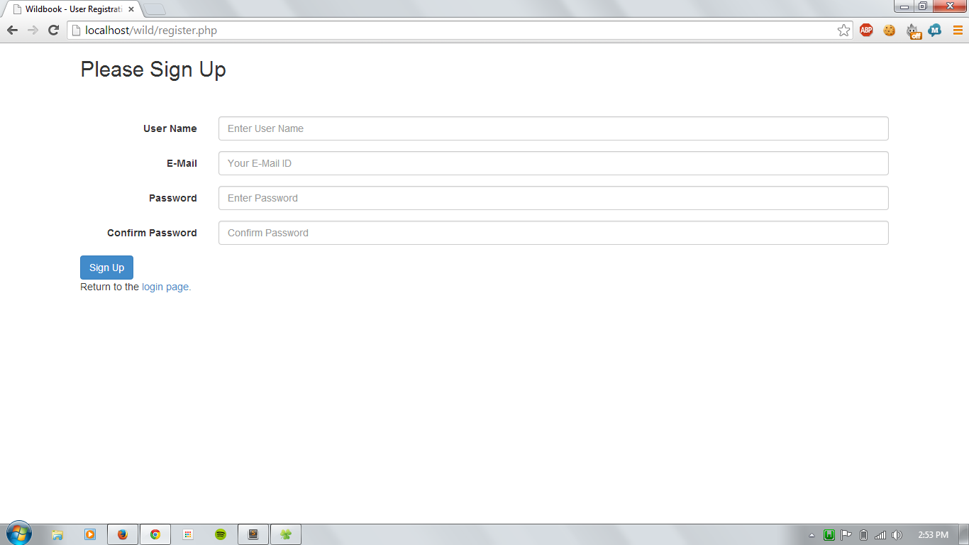

After logging-in home page will look like this:

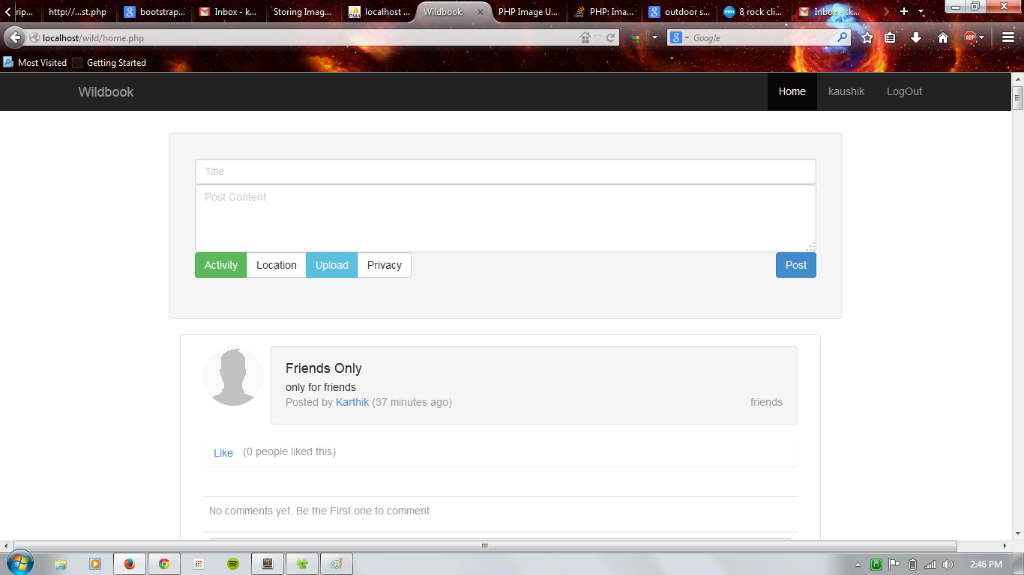

In the friends page, all the list of friends who are accessible is listed here. Friends page will look like this:

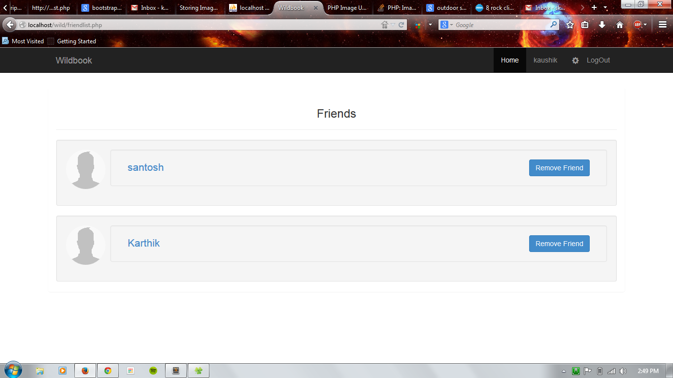

The uploaded image (in the post) will look like this :

